**SOLUTION FOR BANK LOAN PROBLEM**

1. **BANK LOAN REPORT | SUMMARY**

**KPI’S**

1. TOTAL LOAN APPLICATION

SELECT COUNT(ID) AS TOTAL_lOAN_APPLICATIONS FROM bank_loan_data



1. MTD TOTAL LOAN APPLICATION

SELECT COUNT(ID) AS MTD_TOTAL_lOAN_APPLICATIONS FROM bank_loan_data WHERE MONTH(issue_date) = 12 AND YEAR(ISSUE_DATE) = 2021



1. PMTD TOTAL LOAN APPLICATION

SELECT COUNT(ID) AS PMTD_TOTAL_lOAN_APPLICATIONS FROM bank_loan_data WHERE MONTH(issue_date) = 11 AND YEAR(ISSUE_DATE) = 2021



1. TOTAL FUNDED AMOUNT

SELECT SUM(LOAN_AMOUNT) AS TOTAL_FUNDED_AMOUNT FROM bank_loan_data



1. MTD TOTAL FUNDED AMOUNT

SELECT SUM(LOAN_AMOUNT) AS TOTAL_FUNDED_AMOUNT FROM bank_loan_data WHERE MONTH(issue_date) = 12 AND YEAR(ISSUE_DATE) = 2021



1. PMTD TOTAL FUNDED AMOUNT

SELECT SUM(LOAN_AMOUNT) AS PMTD_TOTAL_FUNDED_AMOUNT FROM bank_loan_data WHERE MONTH(issue_date) = 11 AND YEAR(ISSUE_DATE) = 2021

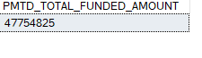

1. TOTAL RECEIVED AMOUNT

SELECT SUM(TOTAL_PAYMENT) AS TOTAL_RECIEVED_AMOUNT FROM bank_loan_data



1. MTD TOTAL RECEIVED AMOUNT

SELECT SUM(TOTAL_PAYMENT) AS MTD_TOTAL_RECIEVED_AMOUNT FROM bank_loan_data WHERE MONTH(issue_date) = 12 AND YEAR(ISSUE_DATE) = 2021



1. PMTD TOTAL RECEIVED AMOUNT

SELECT SUM(TOTAL_PAYMENT) AS PMTD_TOTAL_RECIEVED_AMOUNT FROM bank_loan_data WHERE MONTH(issue_date) = 11 AND YEAR(ISSUE_DATE) = 2021



1. AVG INT RATE

SELECT ROUND(AVG(int_rate), 4) * 100 AS AVG_INT_RATE FROM bank_loan_data



1. MTD AVG INT RATE

SELECT AVG(int_rate)*100 AS MTD_AVG_INT_RATE FROM bank_loan_data WHERE MONTH(issue_date) = 12 AND YEAR(ISSUE_DATE) = 2021



1. PMTD AVG INT RATE

SELECT AVG(int_rate)*100 AS PMTD_AVG_INT_RATE FROM bank_loan_data WHERE MONTH(issue_date) = 11 AND YEAR(ISSUE_DATE) = 2021



1. AVG_DEBT_TO_INCOME_RATIO

SELECT ROUND(AVG(dti), 4) * 100 AS AVG_DTI_RATIO FROM bank_loan_data



1. MTD_AVG_DEBT_TO_INCOME_RATIO

SELECT ROUND(AVG(dti), 4) * 100 AS MTD_AVG_DTI_RATIO FROM bank_loan_data WHERE MONTH(issue_date) = 12 AND YEAR(ISSUE_DATE) = 2021



1. PMTD_AVG_DEBT_TO_INCOME_RATIO

SELECT ROUND(AVG(dti), 4) * 100 AS PMTD_AVG_DTI_RATIO FROM bank_loan_data WHERE MONTH(issue_date) = 11 AND YEAR(ISSUE_DATE) = 2021



1. GOOD LOAN APPLICATION PERCENTAGE

SELECT (COUNT(CASE WHEN LOAN_STATUS = 'FULLY PAID' OR LOAN_STATUS = 'CURRENT' THEN ID END) * 100) / COUNT(ID) AS GOOD_LOAN_PERCENTAGE FROM bank_loan_data



1. GOOD LOAN APPLICATIONS

SELECT COUNT(ID) AS GOOD_LOAN_APPLICATIONS FROM bank_loan_data WHERE loan_status = 'FULLY PAID' OR loan_status = 'CURRENT'



1. GOOD LOAN FUNDED AMOUNT

SELECT SUM(loan_amount) AS GOOD_LOAN_FUNDED_AMOUNT FROM bank_loan_data WHERE loan_status = 'FULLY PAID' OR loan_status = 'CURRENT'



1. GOOD LOAN TOT RECEIVED AMOUNT

SELECT SUM(total_payment) AS GOOD_LOAN_TOT_RECIEVED_AMOUNT FROM bank_loan_data WHERE loan_status = 'FULLY PAID' OR loan_status = 'CURRENT'



1. BAD LOAN APPLICATION PERCENTAGE

SELECT (COUNT(CASE WHEN LOAN_STATUS = 'CHARGED OFF' THEN ID END) * 100) / COUNT(ID) AS BAD_LOAN_PERCENTAGE FROM bank_loan_data



1. BAD_LOAN_APPLICATIONS

SELECT COUNT(ID) AS BAD_LOAN_APPLICATIONS FROM bank_loan_data WHERE loan_status = 'CHARGED OFF'



1. BAD_LOAN_FUNDED_AMOUNT

SELECT SUM(loan_amount) AS BAD_LOAN_FUNDED_AMOUNT FROM bank_loan_data WHERE loan_status = 'CHARGED OFF'



1. BAD_LOAN_TOT_RECIEVED_AMOUNT

SELECT SUM(total_payment) AS BAD_LOAN_TOT_RECIEVED_AMOUNT FROM bank_loan_data WHERE loan_status = 'CHARGED OFF'



1. LOAN STATUS

SELECT LOAN_STATUS, COUNT(ID) AS LoanCount, SUM(TOTAL_PAYMENT) AS TOT_AMOUNT_RECEIVED, SUM(LOAN_AMOUNT) AS TOT_FUNDED_AMOUNT, AVG(INT_RATE * 100) AS INTREST_RATE, AVG(DTI * 100) AS DTI FROM bank_loan_data GROUP BY loan_status

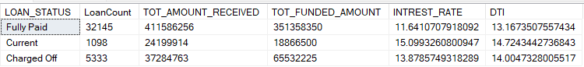

1. MTD LOAN STATUS

SELECT LOAN_STATUS, SUM(TOTAL_PAYMENT) AS MTD_TOT_AMOUNT_RECEIVED,

SUM(LOAN_AMOUNT) AS MTD_TOT_FUNDED_AMOUNT FROM bank_loan_data WHERE MONTH(issue_date) = 12 AND YEAR(ISSUE_DATE) = 2021 GROUP BY loan_status

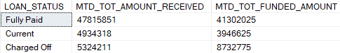

1. **OVERVIEW DASHBOARD**
2. MONTHLY TRENDS BY ISSUE DATE

SELECT MONTH(ISSUE_DATE) AS MONTH_NUM, DATENAME(MONTH, ISSUE_DATE) AS MONTH_NAME, COUNT(ID) AS TOTAL_LOAN_APPLICATIONS, SUM(LOAN_AMOUNT) AS TOT_FUNDED_AMOUNT, SUM(total_payment) AS TOT_AMOUNT_RECIEVED FROM bank_loan_data GROUP BY MONTH(ISSUE_DATE), DATENAME(MONTH, ISSUE_DATE) ORDER BY MONTH(ISSUE_DATE)

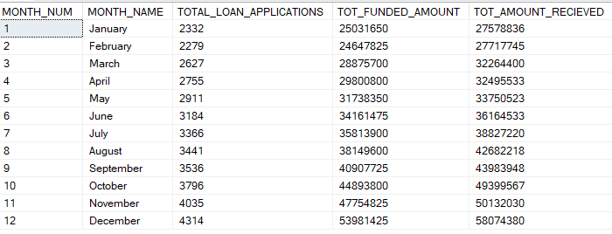

1. REGIONAL ANALYSIS BY STATE

SELECT address_state, COUNT(ID) AS TOTAL_LOAN_APPLICATIONS, SUM(LOAN_AMOUNT) AS TOT_FUNDED_AMOUNT, SUM(total_payment) AS TOT_AMOUNT_RECIEVED FROM bank_loan_data GROUP BY address_state ORDER BY address_state

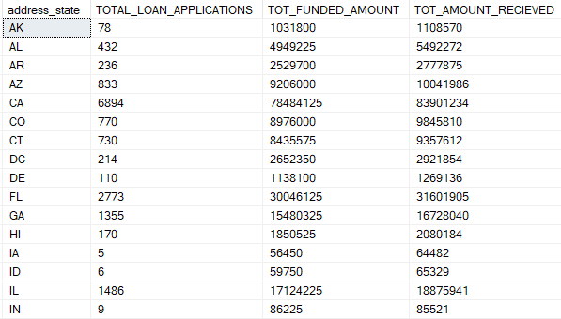

1. LOAN TERM ANALYSIS

SELECT term, COUNT(ID) AS TOTAL_LOAN_APPLICATIONS, SUM(LOAN_AMOUNT) AS TOT_FUNDED_AMOUNT, SUM(total_payment) AS TOT_AMOUNT_RECIEVED FROM bank_loan_data GROUP BY term ORDER BY term



1. EMPLOYEE LENGTH ANALYSIS

SELECT emp_length, COUNT(ID) AS TOTAL_LOAN_APPLICATIONS, SUM(LOAN_AMOUNT) AS TOT_FUNDED_AMOUNT, SUM(total_payment) AS TOT_AMOUNT_RECIEVED FROM bank_loan_data GROUP BY emp_length ORDER BY emp_length

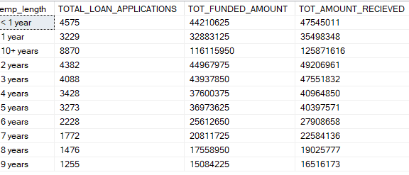

1. LOAN PURPOSE BREAKDOWN

SELECT purpose, COUNT(ID) AS TOTAL_LOAN_APPLICATIONS, SUM(LOAN_AMOUNT) AS TOT_FUNDED_AMOUNT, SUM(total_payment) AS TOT_AMOUNT_RECIEVED FROM bank_loan_data GROUP BY purpose ORDER BY purpose

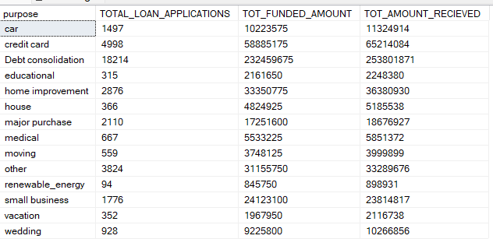

1. HOME OWNERSHIP ANALYSIS

SELECT home_ownership, COUNT(ID) AS TOTAL_LOAN_APPLICATIONS, SUM(LOAN_AMOUNT) AS TOT_FUNDED_AMOUNT, SUM(total_payment) AS TOT_AMOUNT_RECIEVED FROM bank_loan_data GROUP BY home_ownership ORDER BY home_ownership

